LT Spice

Q1)

Open load:

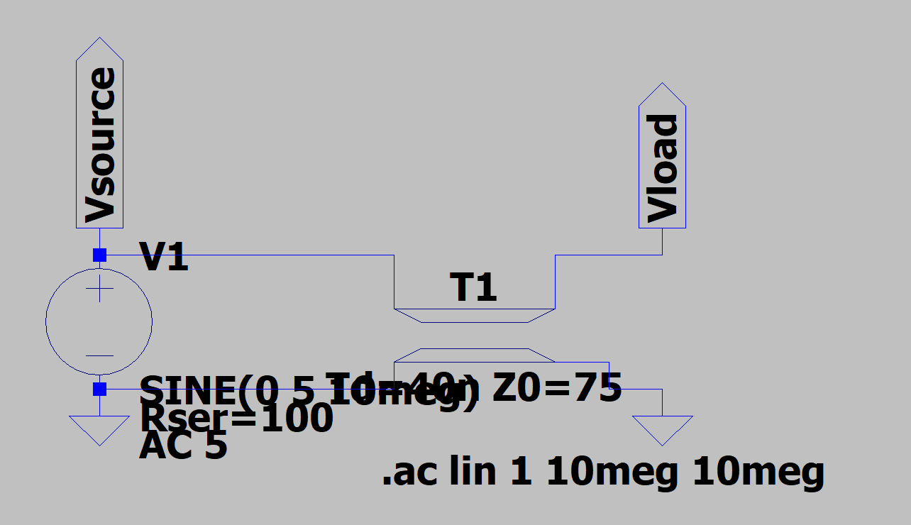

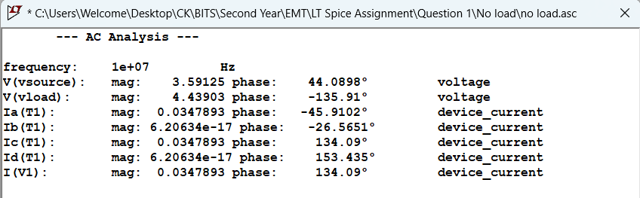

|  |  |  |  |  |
| --- | --- | --- | --- | --- |
| **(i) Open load** | VL (Mag-Ang) | IL (Mag-Ang) | Vin (Mag-Ang) | Iin (Mag-Ang) |
| LTSpice |  |  |  |  |
| Analytical |  |  |  |  |

Short Load:

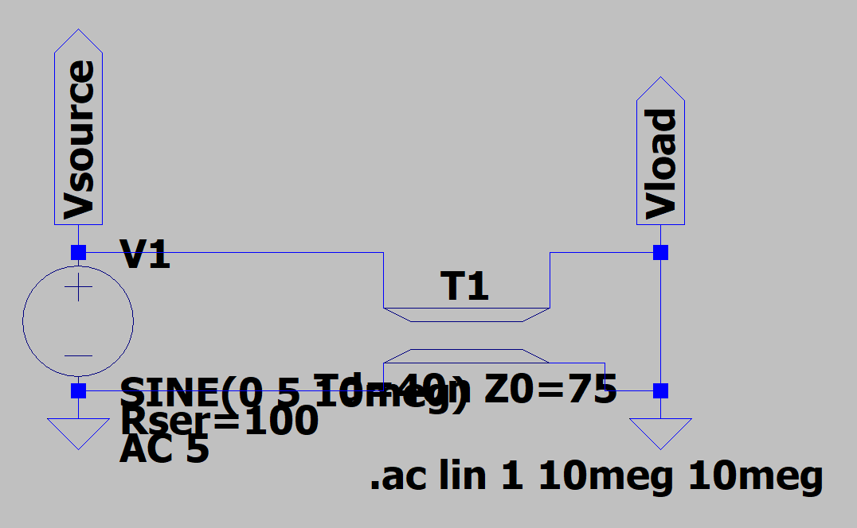

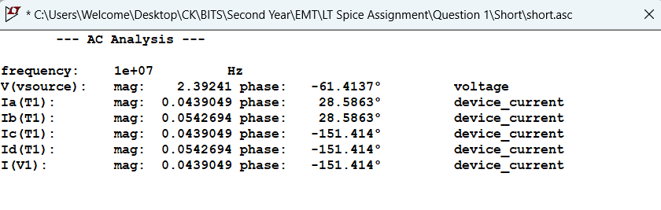

|  |  |  |  |  |
| --- | --- | --- | --- | --- |
| **(i)Short load** | VL (Mag-Ang) | IL (Mag-Ang) | Vin (Mag-Ang) | Iin (Mag-Ang) |
| LTSpice |  |  |  |  |
| Analytical |  |  |  |  |

Matched Load:

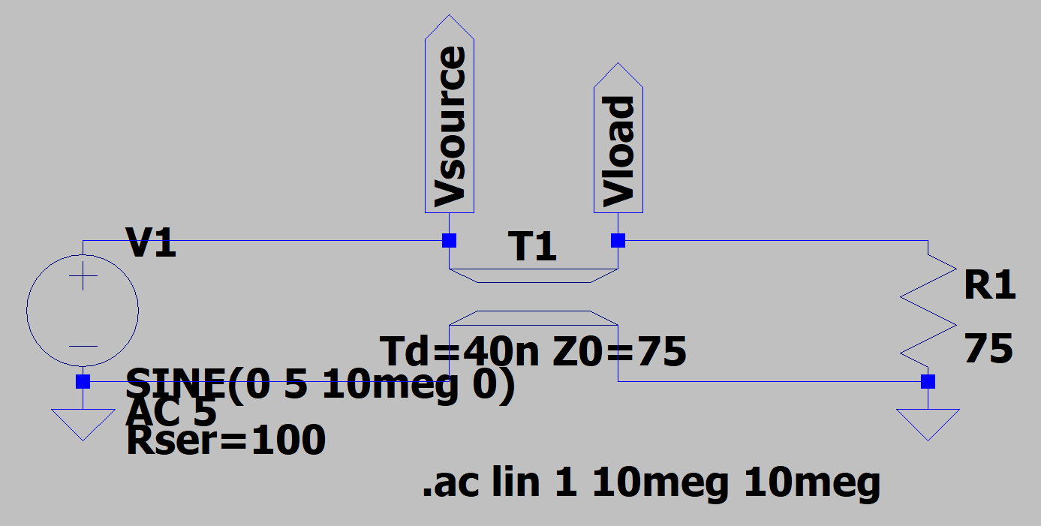

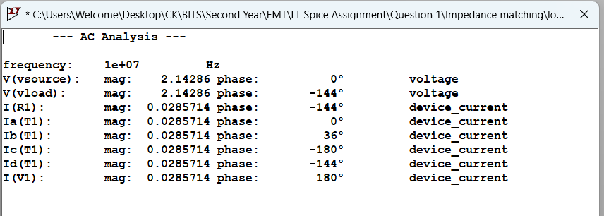

|  |  |  |  |  |
| --- | --- | --- | --- | --- |
| **(i)Matched load** | VL (Mag-Ang) | IL (Mag-Ang) | Vin (Mag-Ang) | Iin (Mag-Ang) |
| LTSpice |  |  |  |  |
| Analytical |  |  |  |  |

Q2)

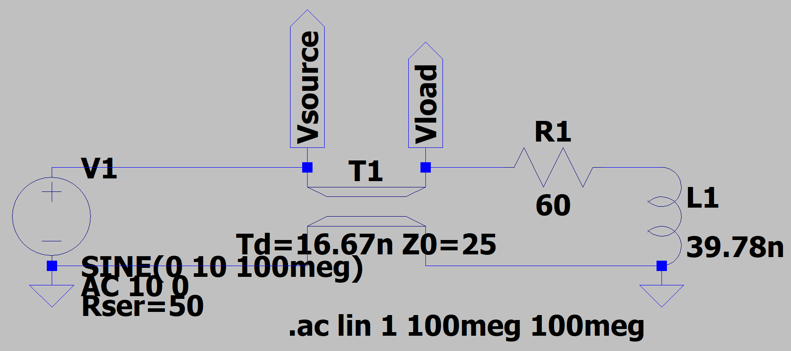

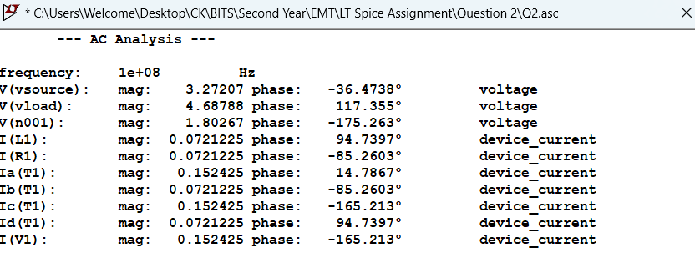

|  |  |  |
| --- | --- | --- |
| Method | Formula Used | Pav (W) |
| 1 |  |  |
| 2 |  |  |
| 3 |  |  |
| 4 |  |  |
| 5 |  |  |
| LT Spice |  |  |